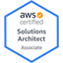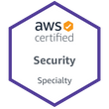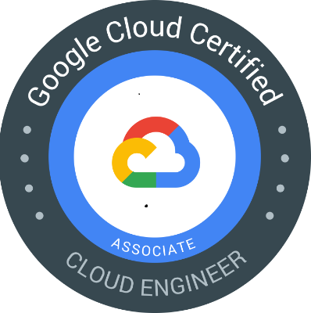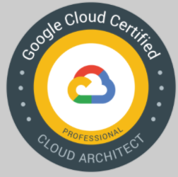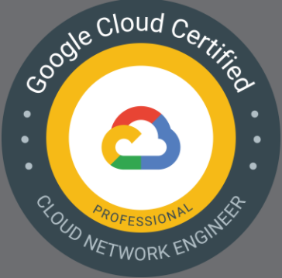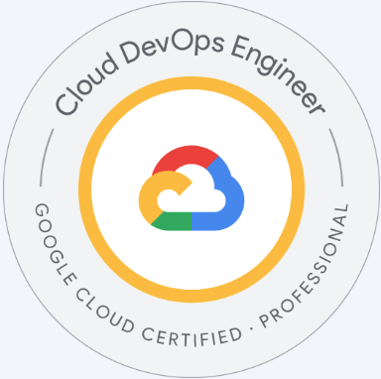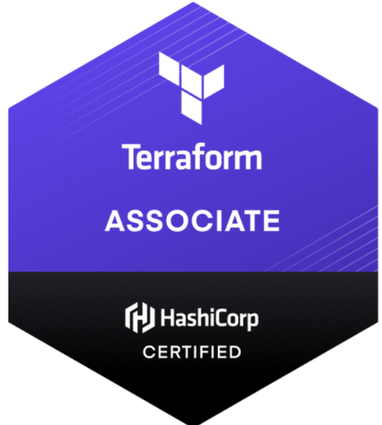

Cesar
Certified DevOps/ Cloud Engineer/ Architect (GCP/ AWS)

Objective:
Understanding and communicating the demands of stakeholders to developers and working on ways to improve and automate the development and release process.

And always open to seeking a challenging position in a reputed organization where I can learn new skills, expand my knowledge, and leverage my learnings.

Professional Summary:

- More than 15+ years in IT. 5 years hands-on experience in AWS/GCP public and private environments.
- More than 4 years of experience using Terraform as IAC
- Extensive experience administering Kubernetes on Cloud using kubectl, Helm Charts and Kustomize
- Efficiency using Docker and Docker Compose as well as very capable of writing Docker files.
- More than 4 years of experience Configuring CI/CD pipelines with Jenkins and skills on CircleCI
- Providing, configuring and maintaining infrastructure in different cloud vendors (AWS and GCP).
- Configuration Management with tools like Ansible and Packer for creation of images
- Good skills on Groovy, Bash and Power Shell and skills in Python to automate process and jobs
- Well versed with UNIX, Red Hat, Ubuntu, Mac OS and Windows.
- Experience with maintaining 24/7 production environments working with teams all over the world
- Excellent communication skills with the ability to interface at all levels. A team player who also can work well independently.
- Good experience leading teams and providing reports of activities on a daily basis
- Experience on NEXUS as Binary and Artifacts Management

Skills:

Cloud | Microsoft Azure, IBM Cloud.
AWS | Load Balancer, VPNs, IAM, EC2, VPCs, SGs, Guard Duty, SQL instances,
GCP | Kubernetes GKE, Load Balancers, VPNs, NAT GW, Dataflow, Bigquery, SQL instances, Cloud Functions, Cloud runs, VPC Connectors, VPC service control perimeter, pub subs, firestone
Containerization | Kubernetes, Docker, minikube, Docker compose, Helm and Kustomize
Monitoring & Alerting | Prometheus, DataDog
Scripting | Groovy, PowerShell, bash and Python
IAC & CM | Terraform, Ansible, Packer, Cloud Formation
CI/CD & VCS | Jenkins, Circle CI and ArgoCD… Git bash
Databases | Dynamo DB, MySQL, PostgreSQL, SQL server
Other | Apache HTTP, Nginx, Web Sphere MQ, YAML, Json
Virtualization | Vmware and Citrix

Education Engineer Electronic and Communications

ESIME “Culhuacán” 1997-2001

Certifications
    - Professional Cloud DevOps Engineer
    - HashiCorp Certified: Terraform Associate
    - Google Cloud Certified - Professional Cloud Network
    - Google Professional Cloud Architect
    - Google Cloud Engineer
    - AWS Certified Security Specialty
    - AWS Certified Solutions Architect - Associate (SAA-C01)
    - Microsoft® Certified Solutions Associate: Windows Server 2012
    - MCTS Microsoft Certified Technology Specialist Exchange 2007
    - MCSE Windows Server 2012

CCA for Citrix XenApp version 6
    - ITIL Foundations V.3, OSA

Work History

Technologia Corporation/ Equifax/ Fannie Mae, Duluth, GA Jun 2022 – Current

DevOps (AWS/ GCP)/ SRE Engineer/ Architect

Activities:
- Architecting and Deploying infrastructure using Terraform as IaC and Jenkins in GCP/AWS.
- Creating Pipelines in Jenkins to import hundreds of existent Resources via terraform, using Groovy Python and Batch for scripting
- Deploying and Managing Resources in Kubernetes using pipelines in Jenkins, Helm Charts and plain YAMLs manifest with Kubectl
- Leading POCs for new strategies of Deployments like Canary and Blue-Green thru Jenkins
- Using Datadog for Monitoring adding Synthetic Services and GCP resources
- Experienced in designing and implementing scalable and highly available containerized solutions using Kubernetes orchestration on Azure.
- Configured and deployed Amazon Web Services (AWS) for a multitude of applications utilizing the AWS stack (Including EC2, VPC, Glacier, Route53, S3, RDS, Cloud Watch, Cloud Trail, IAM, Cloud trail, AWS DynamoDB), focusing on high-availability, fault tolerance, and auto-scaling.
- Skilled in creating and managing Kubernetes clusters on Azure, including configuring networking, storage, and security settings.
- Using Github as SVC and Git bash to pull and push code to deploy Infrastructure and Applications
- Managing and Troubleshooting Jenkins jobs using shared libraries and groovy files
- Working with ISTIO and LinkerD as Service Mesh creating Virtual services, gateways, service entries, destination rules in order to provide a better service with the applications hosted on the GKE cluster
- Managing Argocd as CD to deploy resources in Kubernetes integrated with Jenkins
- Designed and implemented RESTful APIs using AWS API Gateway, integrating with AWS services like Lambda, S3, and DynamoDB.
- Troubleshooting issues with Docker and cloud build to create images and artifacts
- Using NEXUS for uploading artifacts, images and packages for java applications with Maven
- Using Chaosearch to manage and review logs from differents environments
- Troubleshooting GCP\AWS services and assisting other teams in providing new ways to implement or deploy infrastructure.

Activities: Architecting and Deploying infrastructure using terraform as IaC, Git bash and Jenkins as CI/CD, supporting Deloitte in the main office in Pennsylvania

Deloitte, NYC, NY July 2020 – Jun 2022

Senior Cloud (GCP) Engineer / DevOps Engineer

- On GCP Deploying Data analytics services like SQL instances, Bigquery, Dataflows, Composer, Dataproc
- On GCP Deploying server less services like, cloud Runs and Cloud Functions
- Majorly working with CI/CD tools like Jenkins, Code Pipeline, GitLab Pipelines, Azure DevOps, for deployments of AWS EC2, AWS EKS Clusters. Experience in developing Docker file to containerized applications to deploy on managed kubernetes service EKS and AKS
- Deploying & Managing Clusters GKE, using kubectl commands & yaml files to edit, monitor & resolve issues
- On GCP Leading the Networking activities, like deploying HA and Classic VPNs toward Cloud and On-prem, creating FW rules, internal and external FQDNs, reserving static IPs, creating VPC connectors, managing shared VPCs and troubleshooting network issues
- Collaborated with development teams to containerize applications using Docker and orchestrate them with Kubernetes or Azure Kubernetes Service (AKS) on Azure Service Fabric.
- Create Kubernetes clusters using Terraform in Aws-EKS.
- On GCP Deploying Internal and external LBs to expose Compute instances and Serverless resources like Cloud Runs and Cloud Functions
- Helping in creating the code for HashiCorp Packer to create images based on Windows servers with specific configurations
- Important to mention that all these resources have been created via TF, Git and Jenkins.

Environment: AWS, GCP, Jenkins, Git, Terraform, GKE, Bigquery, Serverless connectors, Cloud Runs, Cloud Functions

Atos Global Service, Jan 2012-July 2020

Dallas, TX/ Mexico

Atos/Supporting McKesson Medical Supplies, since Aug 2019 to July 2020,
Cloud Engineer (GCP/ AWS)

Managing AWS and GCP compute instances and services, using an orchestration tool “Ansible” for patching process. Being part of a global Cloud team by India, Mexico, US and Guatemala.

- On AWS Deploying Windows and Linux instances required by projects
- On AWS Creating Security groups needed for connectivity
- On AWS creating and assigning customer roles
- On GCP Deploying infrastructure using Terraform, Git and Jenkins (like EC2, S3, RDS instances, GKS etc.)
- On GCP Creating VPNs (Static, Dynamic) among Cloud and On-prem, internal and external LBs
- On GCP Creating Administering and troubleshooting issues with VPNs, VPCs, FW rules, DNS, Routing, Peering connections, Route 53 and more… all this related with Networking
- Managing Ansible Tower along with WSUS to apply patches on Windows servers

Environment: AWS, GCP, Ansible, Jenkins, Git, Terraform,

Atos/Supporting Schneider Electric since 2012 to Aug 2019
Cloud (GCP) Engineer/ Wintel Admin

Leading the Wintel (AD/Windows Serves) and Virtualization team (Citrix/Vmware) integrated by people from India, Mexico, US and Guatemala managing around 1600 servers, including storages, ESXs and Physical Windows servers with different Brands IBM, DELL and HP, also leading internal projects.

Below a list of activities applied on my current account

- Managing VMWare environment versions 4.5, 5.0, 5.5, 6.5, upgrading and patching ESXs,
- On GCP Pulling reports using gcloud to get a list of firewall rules applied on compute instances
- On GCP Creating FW Rules to allow connectivity
- On GCP Validate IM roles and permissions granted to users
- P2V, V2V for Windows Servers for Main office and distributed sites
- Managing AD, Domain GPOs, applying Security policies, etc
- Managing Citrix XenApp 6.0
- Installing and Managing Physical Windows Clusters 2008, 2012 and 2016
- Generating weekly and monthly performance reports to review with the client periodically
- Improving and fixing issues globally in order to minimize the number of tickets
- Leading Disaster Recovery Wintel Exercises
- Managing Direct attach Modular Disk Storages DELL\Lenovo

Environment: GCP, VMWare, Citrix, AD,

DELL Services, Mexico 2010- 2012

Wintel System Administrator serving Stanford Hospital and Clinics.

- Supporting Stanford Hospital & Clinics for 2 years as System Administrator, part of AD\Wintel\Citrix Team.
- Administering VMWare Environment.
- Administering Storage System Equal logic.
- Creating and modifying GPOs for test and production environment.
- Validating Operational Tasks with DNS, DHCP and AD replication.
- Troubleshooting servers issues with Hardware and Applications.
- Schedule Patching for DCs and APP servers.
- Reviewing and troubleshooting issues with Backup tools, TSM.
- Reviewing and troubleshooting issues with Citrix 4.0 and 5.0
- Scripting to apply GPOs or pull out specific information

Environment: VMware, Citrix.

Fira - System Admin, Mexico 2006 - 2009

- Administering Exchange 2007
- Administering Exchange 2003
- Administering Active Directory 2003
- Administering SQL Server 2005
- Administering SQL Server 2000
- Administering Systems Management Server SMS.
- Administering Windows Server Update Services WSUS.
- Administering VMWare 2.5
- Administering BlackBerry System Manager
- Administering CITRIX v.3.0

Televisa S.A. de C.V. - System Admin , Mexico 2004 - 2005

- Administering BlackBerry System Manager
- Administering Fax Server
- Analysis and Implementation of Windows Projects.
- Help to VIP users on news technologies.
- Analysis and Migration of Windows Servers.

